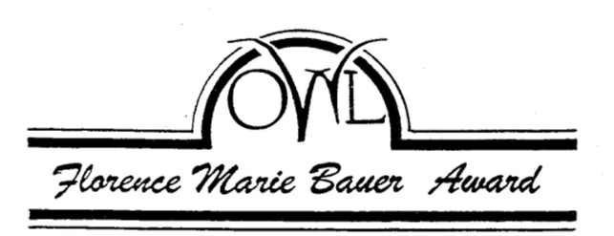

OWL Scholarship Committee
c/o Ms. Helen Winkler
1742A NW 59th St.
Seattle, WA 98107
hoot@scn.org

Guidelines for Florence Marie Bauer Scholarship

Scholarships in the amount of $2000 will be awarded to successful candidates by the Seattle/King County Older Women’s League, (OWL). The award will be issued for the fall quarter through the Financial Aid Office of the college the student will be attending.

An application for fall 2016 must be completed and postmarked to the scholarship committee by April 30, 2016.

The candidate must be a mature woman over 40 years old. She must be a resident of Seattle/King County and attending a Washington state accredited college. Our awards go to women who for whatever reason must train to support themselves. Our goal is to assist women who are striving to achieve financial independence through education and training.

Special consideration will be given to candidates with a career goal of working in the gerontology field.

Applicants must have clearly defined educational and career goals and be able to articulate them to the scholarship committee.

Please send completed applications to:
OWL Scholarship Committee
c/o Helen Winkler
1742A NW 59th St.
Seattle, WA 98107

OWL…THE VOICE OF WOMEN 40+

OWL Scholarship Committee
c/o Ms .Helen Winkler
1742A NW 59th St.
Seattle, WA 98107
hoot@scn.org

Application for Florence Marie Bauer Scholarship

Name________________________________________________________________

Address______________________________________________________________

Phone number_________________________________________________________

Student Identification Number ___________________________________________

Age__________________________________________________________________

Email address_________________________________________________________

Briefly tell us about yourself:
Your previous education. List dates, institutions and degrees obtained.
Current living situation.
Your employment experience or volunteer activities. Include dates, positions and responsibilities covering the last 10 years.
Your career and education goals. Indicate specific time lines.

Please send three letters of recommendation. These could be from former or present employers or teachers.

Tell us: The school you are registered in or plan to attend.
The name of your counselor and/or financial aid advisor.
Where applicable: A statement that you are currently registered in the Gerontology Certificate program.

Please send this information postmarked by April 30, 2016 to:
OWL Scholarship Committee
c/o Helen Winkler
1742A NW 59th St.
Seattle, WA 98107

